

Maximo extensions for Building Information Models

Autodesk Forge Viewer Plug-in

For Maximo 7.6.0.8

Technical contact: Doug Wood [doug.wood@us.ibm](mailto:doug.wood@us.ibm).com

Marketing Contact Kawon Park [[kpark@us.ibm.com](mailto:kpark@us.ibm.com)](mailto:kwoodbur@us.ibm.com)



The Maxim extensions for Building Information Modeling (BIM) is released as trial software and distributed on the IBM Service Management (ISM) Library. An existing Maximo Asset Management 7.5 or 7.6 license and installation is required. Trial software is not supported by the IBM Maximo support program; however, support is available directly from the IBM Maximo development team for as long as the software is available for download on the ISM Library. Check the ISM Library for the most recent version as well as continued availability. Only an English version is distributed during the trial. Your feedback is important because the software is being evaluated for possible integration with other Maximo products. Send all support questions and feedback to: [maxbim@ca.ibm.com](mailto:maxbim@ca.ibm.com)



**© Copyright International Business Machines Corporation 2011.**

US Government Users Restricted Rights – Use, duplication or disclosure restricted by GSA ADP Schedule Contract with IBM Corp.

Contents

List of Figures v

1 Overview 2

1.1 Utilizing Building Information Modeling (BIM) models with Maximo 2

1.2 Supported Software 3

1.3 Features 3

1.4 Known Limitations 6

2 Model Administration 6

2.1 Managing Model Storage 8

2.1.1 Creating a storage container: 9

2.1.2 Unlinking a Storage Container 10

2.1.3 Deleting a Storage Container: 11

2.2 Rights 11

2.3 Managing Model Files 12

2.3.1 Upload Model 13

2.3.2 Linking Models 14

2.3.3 Unlink Model 15

2.3.4 Delete Model 15

2.4 Working with multi-file models 15

2.5 Manage Viewable Models 15

2.6 Managing Associated Locations 19

2.7 System Properties 20

3 Using the Autodesk Forge Viewer 21

3.1.1 Locating Model Files 22

3.2 Viewer Navigation 22

3.2.1 Maximo context 22

3.2.2 Top Toolbar (Location and Assets) 23

3.2.3 Saved views 26

3.2.4 Asset Properties 28

3.3 Viewer Navigation 30

3.3.1 Viewer Toolbar 30

3.3.2 Model Tree 32

3.4 Sections 33

3.5 Geo Positioning 33

3.6 Work Order Tracking 34

3.6.1 Markup 35

4 Security 38

5 Trouble Shooting 39

5.1 Forge Viewer 39

6 Appendix REST API support 39

6.1 Service Methods 39

6.2 Object Structures 40

7 Appendix – Summary of Database updates 41

7.1 Tables Created: 41

7.2 Synonym Domains Added 41

List of Figures

Figure 1 – Model viewer embedded into the Maximo Locations application 5

Figure 2 - The Model viewer for work order dispatch 6

Figure 3 - Model files and locations 22

Figure 4 - Edit Systems Dialog 26

**Executive Summary**

The Maximo® Extensions for Building Information Models (BIM) - Autodesk Forge Viewer Plug-in provides support for utilizing the Autodesk Forge Viewer in Maximo. It is most easily utilized in conjunction with COBie data that is imported in the BIM Projects application.

The Forge Viewer integration provides visualization of Building Information Model (BIM) data in the context of the Maximo Assets, Locations, and Work Order Tracking applications. In this context, it provides the following features:

**Forge Service Administration**

A UI for administering the Autodesk Forge service as used by Maximo including:

* Managing storage containers (Autodesk Forge Buckets)
* Uploading models to the Autodesk Forge service
* Linking multi-part models
* Translating models into viewable formats

**Maximo Integration**

* + Model file management - the viewer automatically displays the correct model file(s) for a selected Maximo location or asset. If there are multiple models available, a list is provided, and most of the context is maintained when switching between models.
  + Viewer context is synchronized to Maximo (locations and assets) - selecting a record in Maximo selects the corresponding item in the Viewer which zooms and centers the 3D model on that item.
  + Maximo context is synchronized to the Viewer (locations and assets) - selecting an item in the Viewer causes the corresponding record in Maximo to become the current Maximo record
  + The Viewer can be used as an asset selection lookup anywhere in Maximo where an asset look-up menu is available.
  + The Viewer can be used to select a set of assets to add to a service request or work order.
  + You can create service requests and work orders directly in the Viewer
  + You can search a facility for open work orders, preventative maintenance work, and service requests, and display all or a selected set of the search results as the selection set in the Viewer.
  + You can display members of Maximo systems in the Viewer - search from systems and zones either that are either defined for the facility, or for which the selected item is a member. You can display all members of the system as the current selection or drill-down to any member of the system and select it in the Viewer.
  + You can create and edit Maximo systems from the Viewer - the selection set in the Viewer can be used to either create a new system or be added as a sub-tree to an existing system.
  + You can navigate through a multi-item selection set changing both the model view (zoom and center), and the current Maximo record to the current item in the set.
  + You can markup a view in the Viewer, save the markup with a Work Order, and then display the markup any time the work order is viewed.

**Forge Viewer features that are exposed in the Viewer toolbar include:**

* + Full 3D navigation
  + Basic search
  + Model properties
  + Model tree
  + Sectioning of a model
  + Model walk through
  + Save and restore views

For further discussion and participation please join our [forum](http://www.ibm.com/developerworks/forums/forum.jspa?forumID=2981) and subscribe to the following groups located at [Service Management Connect Community](https://www.ibm.com/developerworks/servicemanagement/).

* [Asset Management](https://www.ibm.com/developerworks/servicemanagement/am/index.html)
* [Real Estate and Facilities Management](https://www.ibm.com/developerworks/servicemanagement/rfm/index.html)

**Change History**

#### Version 7.6.0.6

New

#### Version 7.6.0.7

Update for new Model Management features for Redlining/Markup in Work Order Tracking application.

#### Version 7.6.0.8

Updates for Forge API changes

# Overview

## Utilizing Building Information Modeling (BIM) models with Maximo

Building Information Models are an industry representation of a building that are used during the design and build phases of building construction. The data model provides the information in its attributes to describe (in detail) the infrastructure of a building. The use of data models is becoming more frequently used by contractors and is part of the turnover of a building to the owner. A model that is provided at turnover is generally referred to as the “as built” state of the building.

Building owners who are commissioning a building into production need the information in this model to perform facilities management. The process of loading this information into your maintenance products, such as Maximo, is costly, time consuming, and may introduce errors. The code contained in this package allows you to automatically load the data in the BIM model into Maximo to begin the process of maintaining the building. This state is referred to by “as maintained”.

When the data is imported, this package provides 3D visualization of the full building model in context with the imported data. This improves the efficiency of the maintenance, work planning, and execution process. Finally, the data, with any changes made during operations may be exported to update the model for a renovation project, or for use in other tools.

## Supported Software

The Maximo BIM Forge Viewer Plug-in is offered as trial software which is not supported by the IBM Maximo support program; however, support is available directly from the IBM Maximo development team for as long as the software is available for download on the ISM Library. Send all support questions and feedback to: [maxbim@ca.ibm.com](mailto:maxbim@ca.ibm.com)

**Maximo™**: Officially supported Maximo versions are 7.6.0.6 and upwards.

**Autodesk Forge Viewer:** The Autodesk Forge Viewer is a cloud-based Viewer. To use it in Maximo, a subscription from Autodesk is required. The Forge Viewer requires a browser that supports WebGL. Tested browsers include: Microsoft Edge, Internet Explorer 11, Firefox v42.0, and Chrome v47.0.

## Features

The Forge Viewer integration provides visualization of Building Information Model (BIM) data in the context of the Maximo Assets, Locations, and Work Order Tracking applications. In this context, it provides the following features:

**Forge Service Administration**

A UI for administering the Autodesk Forge service as used by Maximo including:

* Managing storage containers (Autodesk Forge Buckets)
* Uploading models to the Autodesk Forge service
* Linking multi-part models
* Translating models into viewable formats

**Maximo Integration**

* + Model file management - the viewer automatically displays the correct model file(s) for a selected Maximo location or asset. If there are multiple models available, a list is provided, and most of the context is maintained when switching between models.
  + Viewer context is synchronized to Maximo (locations and assets) - selecting a record in Maximo selects the corresponding item in the Viewer which zooms and centers the 3D model on that item.
  + Maximo context is synchronized to the Viewer (locations and assets) - selecting an item in the Viewer causes the corresponding record in Maximo to become the current Maximo record
  + The Viewer can be used as an asset selection lookup anywhere in Maximo where an asset look-up menu is available.
  + The Viewer can be used to select a set of assets to add to a service request or work order.
  + You can create service requests and work orders directly in the Viewer
  + You can search a facility for open work orders, preventative maintenance work, and service requests, and display all or a selected set of the search results as the selection set in the Viewer.
  + You can display members of Maximo systems in the Viewer - search from systems and zones either that are either defined for the facility, or for which the selected item is a member. You can display all members of the system as the current selection or drill-down to any member of the system and select it in the Viewer.
  + You can create and edit Maximo systems from the Viewer - the selection set in the Viewer can be used to either create a new system or be added as a sub-tree to an existing system.
  + You can navigate through a multi-item selection set changing both the model view (zoom and center), and the current Maximo record to the current item in the set.
  + You can markup a view in the Viewer, save the markup with a Work Order, and then display the markup any time the work order is viewed.

**Forge Viewer features that are exposed in the Viewer toolbar include:**

* + Full 3D navigation
  + Basic search
  + Model properties
  + Model tree
  + Sectioning of a model
  + Model walk through
  + Save and restore views

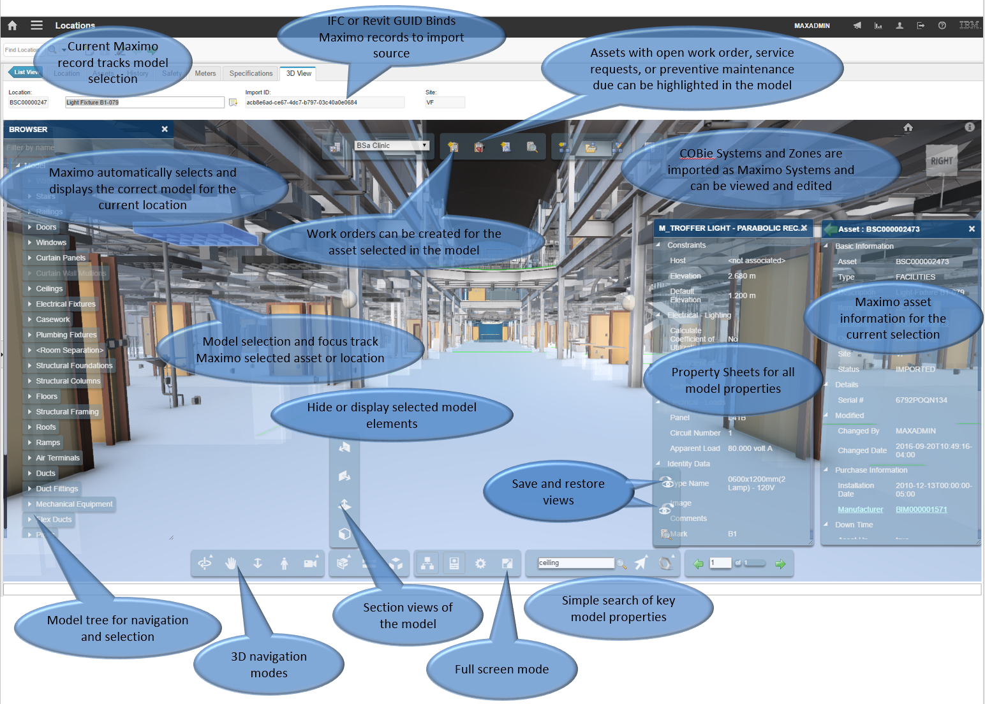

Figure – Model viewer embedded into the Maximo Locations application

In addition, the 3D model can be used in conjunction with the normal Maximo lookup mechanism to provide direct visual selection of assets from a building model.



Figure - The Model viewer for work order dispatch

## Known Limitations

* In the Forge Viewer, large models can generate out of memory errors especially in browsers on low memory devices, such as tablets. This can manifest as a console error message or a browser crash.
* For the Forge Storage Management, rights granted on storage to other IDs do not in fact grant them rights.
* In the Work Order Tracking application, if the side menu is open, the Viewer displays incorrectly on top of the navigation trees. When the side menu is closed, the Viewer displays correctly.
* On Windows, zooming the browser or using display setting of other than %100 font and app size cause the Viewer to be incorrectly positioned in the Work Order Tracking application.

# Model Administration

Model administration is performed from the Manage BIM Viewer application which is found under the Building Information Models module.

There are 4 or 5 steps required to view a model with the Forge Viewer from within Maximo, depending on the complexity of the model:

1. Create one or more storage containers in the Forge service to hold the model files. For the purpose of a demo, only one storage container is required. If you manage models for multiple companies, you should create additional container to organize you models and to apply Maximo security to groups of models.
2. Uploaded the model files(s) to the Forge service.
3. If the model is multi-part, associate the linked parts with the master part.
4. Request that the Forge service translate the model into a viewable format.
5. Associate the viewable model with the Maximo location for the facility that is represented by the model. This location is typically created using a COBie import in the BIM Projects application.

Some of the above steps may have been performed outside the current Maximo instance. If so, steps 1, 2, and 4 can be replaced by linking to existing objects in the Forge service.

#### Linking Maximo records with Forge Service records

The Forge Service objects described below: storage container, model file, and model viewables, are each composite objects. That is some of the data for each object resides in the Forge Service and some of the data resides in the Maximo database. Each Maximo database record has a reference or link to the Forge Service portion of the data.

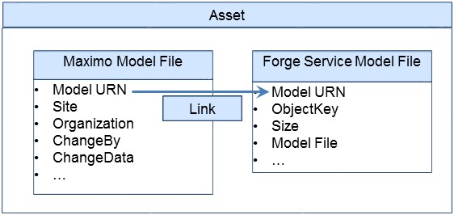

When Forge Service objects are created though the current Maximo instance, the Maximo record and the Forge Service object are created at the same time and the linking is transparent to the user. However, if the Forge Service objects are created through some other application including other Maximo instance such as a test or development server, Then the Maximo part of the data still needs to be created, and it must be manually linked to a Forge service object.

#### Model data and the Autodesk Forge service

Some model information such as site and organization data is stored in Maximo. Other information is retrieved from the Autodesk Forge service each time a record is loaded from the Maximo database.

As the Autodesk Forge Service, may not always be reachable or models in the cloud may be altered outside of Maximo, each record that is linked to the Autodesk Forge service data includes an Online checkbox.

When the Online check box is checked, the Autodesk component of the data was successfully retrieved. Each record also includes a Last Error field that is populated with any error data either from attempting to access the Autodesk Forge service, or returned from it.

## Managing Model Storage

The Forge service uses storage containers (called buckets by Forge) to store any model files that are uploaded to the service. A storage container is similar to a directory in a file system. To use the Forge service, you must create at least one storage container.

To manage model storage containers, navigate to the Manage BIM Viewer application.

Navigate to Select Actions > Manage Autodesk Forge Service > Manage Model Storage.

#### 

### Creating a storage container:

1. To create a storage container, in the Manage Model Storage dialog select the Create Storage button.

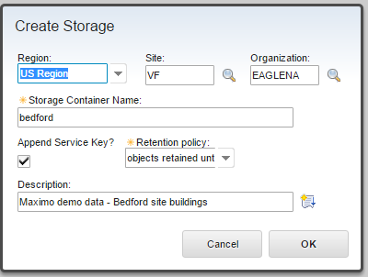

1. Specify a Region**.** Containers may be created in the US or the EMEA region of the Forge service. If no region is specified, US is used.
2. Optional: Specify a site and organization**.** A Maximo organization or site and Organization can be associated with a storage container. Within the current Maximo instance, access to the storage container is restricted to Maximo users that have rights to the listed site and organization. Models loaded into the container and viewables derived from the model must have the same or more narrow restrictions. Ultimately any location that is associated with a viewable model must meet the site and organization restriction that is specified on the storage container. However, if the storage container is accessed outside of Maximo, or linked to a different Maximo instance, the restrictions are not carried over.
3. Specify a storage container name and description**.** Names must be unique across the Autodesk Forge service including all Autodesk Forge users. To facilitate this, Maximo can append your Autodesk Forge service key to your storage container name. If you select this option, only the base name is displayed on the UI. If you don’t select this option, it is highly recommended that you include some unique string that is associated with you company or organization, such as a registered domain name, in your storage container names.
4. Unless you design your own strategy to ensure your storage names are unique across the entire Forge Service, you should leave the Append Service key checkbox checked.
5. Select the desired retention policy and click OK. There are three types of storage containers:

**Transient:** Model files are retained only for 24 hours

**Temporary:** Model files are retained only for 30 days

**Permanent:** Model files are retained until they are deleted.

**Note:** If a model has been translated to a viewable format and is then remove, including through its storage period expiring, the viewable format is not removed.

Maximo site security can be applied to storage containers by selecting an organization, or a site and an organization. If either is specified, only users that have rights to the site or organization can view the storage container in Maximo.

#### Linking to a storage container

If a storage container already exists, for example: it was created for use with TRIRIGA, or it was created in a development deployment and now needs to be moved to production, it can also be used by Maximo by linking to it.

1. To link to an existing storage container, select the Link to Storage button in the Manage Model Storage dialog.

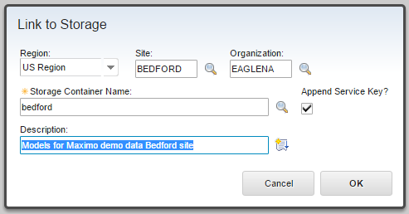

1. Specify a region**.** The region is used to filter the storage container name in the lookup list. It is only possible to view a list for a single region. If no region is specified, the US is used by default.
2. Optional: You can specify a site and organization therefore, restricting the access as indicated previously.
3. Specify a storage container name**.** In the lookup, the storage container name may be selected from a list of all storage containers in the selected region that are not already registered in Maximo. Otherwise, you can manually enter a name.
4. The service key that is configured for Maximo does not need to own the storage container, however, that key must have rights to access the specific storage container.
5. Click OK.

Note: you can link to the same storage multiple times to apply different site or organization restrictions.

### Unlinking a Storage Container

A storage container may be unlinked from Maximo by selecting the unlink icon . Unlinking a storage container makes it unavailable for further use in Maximo. It does not remove any model files from the storage container nor does it remove any models that are in the container from the list of models that are available in Maximo.

### Deleting a Storage Container:

A storage container can be deleted. Deleting a storage container also deletes everything that is stored in it**. This process CANNOT be undone**. Models and Viewable format listings in Maximo that reference objects in the container are also deleted.

.

You must select all three checkboxes to acknowledge that all items can be deleted before the delete action is performed.

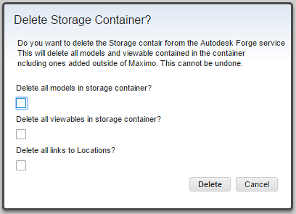

## Rights

Rights to a storage container may be granted to other service keys. To grant rights, in the Manage Model Storage dialog, click the Grant Access button.

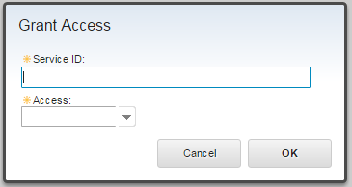n

1. For the Service ID, specify an Autodesk Forge service key. The Autodesk Forge service provides no indication of whether a service key is valid or not.
2. Specify an access level: The options are full or read only.

To remove access, click the trash can to delete the row. The row is deleted immediately.

Actual rights granted are currently very limited.

## Managing Model Files

Any type of file can be uploaded to a storage container. However, only those file types that can be translated into viewable format are of interest here.

#### 

### Upload Model

1. To upload a model file, click the Upload Model button.

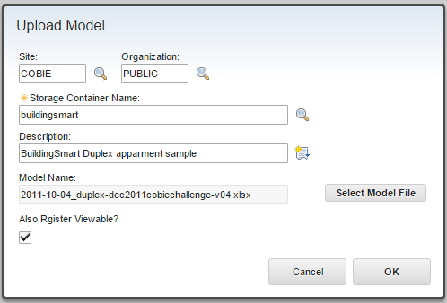

1. Specify an organization or a site and organization if you want to restrict access to the model. If you specify either, then the list of storage containers is filtered to only show those with origination or site and organization matching what you specified. Changing the site or organization after the storage container has been selected clears the Storage Container Name field so site and organization restrictions are enforced.
2. Specify a storage container name and description. The name should be the same unique name that you previously used to create a storage container. The model name is the base filename name and extension converted to lower case. If model parts are to be linked (See below) the base file names that are used must be the same as the file names that are used for the links in the model files.
3. Select a model file to upload. Model upload is a two-stage process. First the model is uploaded from the local workstation to the Maximo server then from the Maximo server to the Autodesk Forge service. The transfer from the Maximo server to the Autodesk Forge service happens in the background and is resilient to communication interruptions.
4. If the model is a single file selecting the Also Register Viewable checkbox cause the model to be automatically submitted to the Forge Service for translation and eliminates the need to manually perform the viewable registration process. If it is necessary to assemble linked files (See below) then leave this unselected.
5. Click OK and you are returned to the Manage Model dialog.
6. Optional: You can monitor progress on the model upload by clicking the Refresh button in the Upload History table in the Manage Model dialog.

If the model consists of more than one file, upload all the files in the model then see

If the model already exists in the storage container, you are prompted to overwrite it.

### Linking Models

Models that were upload by using other applications such as another instance of Maximo or by using TRIRIGA need not be uploaded again. Instead they can be linked to Maximo.

1. To link to a model, in the Manage Models dialog click the Link to Model button.

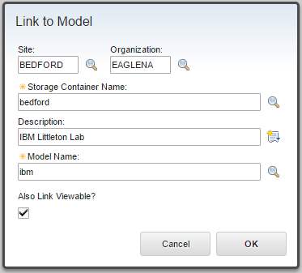

1. Specify an organization or a site and organization if you want to restrict access to the model. If you specify either, then the list of storage containers is filtered to only show those with origination or site and organization matching what you specified. Changing the site or organization after the storage container has been selected clears the Storage Container Name field so site and organization restrictions are enforced.
2. Specify a storage container name and description. Select the storage container in which the model that you want to link resides.
3. Specify a Model Name. The model name may either be manually entered or selected from a list of model in the container retrieved from the Forge service. If the lookup is used, the list can be filtered by entering a value in the model name field before displaying he lookup. Only model names that start with this value are shown.

If the model name is manually entered, it is validated when the dialog is accepted. If the selected storage container is owned by a different Forge application and rights are granted to the appellation key used by Maximo, it is possible to link to models in that container. However, the storage container is not searchable so the lookup displays an empty list and the model details are not visible so the model shows as off line.

If a viewable format for the model exists, it can be linked at the same time by selecting the Also Link Viewable check box. If a viewable doesn’t exist, then follow then same steps used after a model is uploaded to link together its component parts and register it. see

### Unlink Model

A model file can be unlinked from Maximo by selecting the unlink icon . Unlinking a model makes it unavailable for further use in Maximo. It does not remove any translated viewable model from Maximo.

### Delete Model

Model files may be deleted from a storage container by deleting the row. Unlike deleting records from the database, the action happens immediately and the row cannot be undeleted. If the model file has been translated to a viewable format, deleting the model file does not delete the viewable format. Deleting models after translation or by using a temporary or transient storage container is a good means to reduce storage cost.

## Working with multi-file models

Some modeling tools such as Revit have workflows that distribute a model across many files that are then linked to form the complete model. For example, a model may be divided into an architectural, an MEP, and a structure component each in different Revit files. The Forge service can integrate these parts into a single model for display in the Forge viewer. To do so, the following perform the following steps:

1. Gather the files composing the model into a directory tree that can easily be converted into a .zip file. Ideally you should remove extraneous files such as auto-save files.
2. Select the file that will be the master file for the linked model. In sure that all linked parts or sub-model files load correctly when this file is opened.
3. Convert the directory containing the model files into a .zip archive.
4. Up load the .zip archive as described above. Don’t select to auto-register the viewable
5. Open the manage viewable Models dialog as described below.
6. Follow the “Register Model as Viewable” procedure below selecting the .zip file containing the model as the file to register.
7. Select the compressed option
8. Enter the name of the file from step 2 as the root file name

## Manage Viewable Models

Before models can be used in the Viewer, they must be registered and translated into the format that is used by the Viewer. Typically, only the default 3D view is translated so before the model is uploaded, it should be saved with the desired view as the default. For Autodesk NavisWorks, this is the view that is displayed when the .nwd file is opened. For Autodesk Revit, it is the default view which appears similar to:

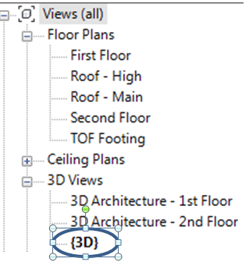

If the Revit file has linked models and the linked models are to be shown, the default view must include the linked models. This can be enabled in Revit by right clicking on the view to display its properties, selecting the Edit button on the Visibility/Graphics override property, and then selecting the Revit Links tab.

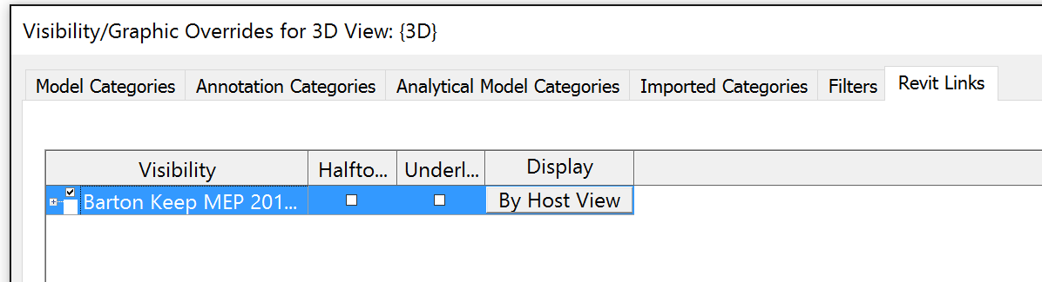

The Manage Viewable Models dialog has a list of all models that have completed the translation process and are ready to be displayed in the Viewer. It is also used to request the Autodesk Forge Service to translate and to monitor the status of the translation process.

#### 

#### Register Model as Viewable

1. To register a model as a viewable format, in the Manage Viewable Models dialog click the Register Viewable button.
2. Optional: Specify a site or organization.
3. Specify the model name and a description. The models name must have previously been linked or uploaded and appear in the Manage Models table. Only models that match the selected site and organization are displayed.
4. If the model is a multi-file model uploaded as a .zip file (See 2.4 Working with multi-file models), Select the compressed options and enter the root file name
5. Click OK.

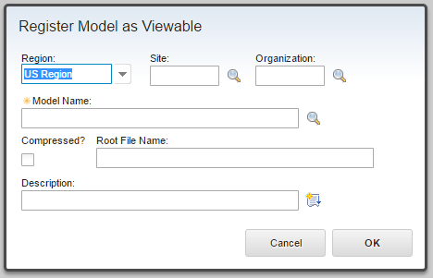

Model translation and registration occurs in the background in the Autodesk Forge service.

5. Optional: You can monitor the progress of the translation progress by clicking the Refresh button for the model that is being translated in the Manage Viewable Models dialog.

**Linking to Existing Viewable Formats**

Existing viewable formats can be linked to Maximo. To link a viewable, the model must be defined in Maximo either by linking or by uploading a model.

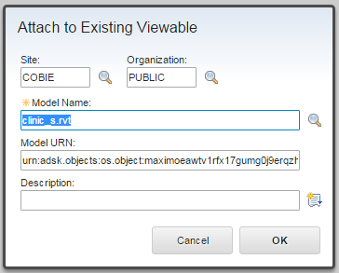

1. To link to an existing viewable format, in the Manage Viewable Models dialog click the Link to Viewable button.

Optional: Specify a site or organization. Changing the site or organization clears the Model name and URN fields so only models for sites to which the user has access can be linked.

1. Specify the model name. The models name must have previously been linked or uploaded and appear in the Manage Models table. Only models that match the selected site and organization are displayed The URN is automatically populated from the selected model record.
2. Optionally, specify a description.
3. Click OK.

## Managing Associated Locations

Model files can be associated with locations, and existing associations can be edited either in the Manage BIM Viewer application or from the Add/Edit Model dialog that is launched from the Viewer in the Locations application. The Manage BIM Viewer application is launched form Goto >Building Information Modeling >Manage BIM Viewer. The Add/Edit Models dialog is launched from the  icon on the Viewer in the Locations application. This icon is on the top left of the Viewer (See 3.2.2 Top Toolbar)

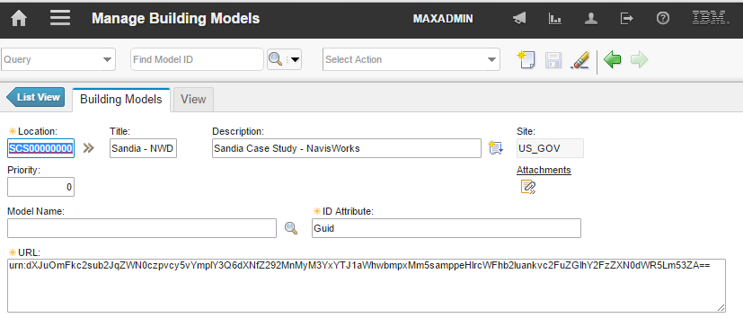

1. Specify a location, title, and description. The location is typically the facility that is created by a COBie import of data that is extracted from a model.
2. Specify a model name. The model name is selected from the list of registered viewable formats. The site and organization specified must be compatible with the site and organization for the selected location.

When multiple models are available for a location or asset, each model must be individually associated with the location. When displayed in Maximo, the models are sorted in the model dropdown in order of priority, and the highest priority model is loaded when the Viewer is displayed.

1. The ID Attribute field is not used for Revit models. For other types of models, it is the name of the property that is expected to contain the unique ID that matches with the Maximo model ID that is imported from COBie. It is case sensitive. For NavisWorks files, this is typically either Guid or GUID depending on the version of NavisWorks that was used to create the file.

## System Properties

There are several system properties that are related to the Forge Viewer.

#### Requesting Autodesk Forge Account Credentials

The Autodesk Forge Viewer is a cloud based WebGL application. To use it you must create an account with Autodesk and credentials for the Autodesk Forge service application. The credentials must be provided to Maximo by entering them into the Maximo System Properties application.

Maximo does not support BIM360. These require individual user authentication for each access and this is not compatible with the server based interactions Maximo uses with the Forge Service.

1. Navigate to this website: <https://developer.autodesk.com/>
2. Create an account specifying an application that you want to create the account for. The callback URL is not used.
3. Note the key and secret that are provided by Autodesk.

To configure system properties, navigate to:

1. System Configuration > Platform Configuration > System Properties.
2. Click the filter to specify a value.
3. Specify bim in the Property Name filter field and press enter.
4. Click the bim.viewer.LMV.key property and specify the key that Autodesk provided.
5. Click the bim.viewer.LMV.secret property and specify the secret that Autodesk provided.
6. When you have updated properties as described below, select the box to the left of the properties you have edited to select them and select the Live Refresh button from the toolbar.

#### Maximo model upload size

The bim.viewer.LMV.model.maxuploadsize property controls the maximum size of a model file in megabytes that can be uploaded to Maximo.

#### Viewer Default Theme

The Viewer supports user selectable visual themes. This setting defines the default theme that is used before any user selections. Themes are displayed in a selection list in the Viewer settings. They are numbered sequentially starting with 0. To specify a default theme, enter the theme number in this setting:

*bim.viewer.LMV.theme*

#### Forge API Configuration

The following system properties control how the Forge API is accessed and the version of the Autodesk Forge services that is used by Maximo. By default, these properties reference the version with which the Maximo BIM solution was tested. They are not normally changed other than by an install or upgrade process.

* bim.viewer.LMV.host
* bim.viewer.LMV.api.version
* bim.viewer.LMV.api.version.auth
* bim.viewer.LMV.viewer.version

# Using the Autodesk Forge Viewer

The Autodesk® Forge Viewer is integrated into the Maximo UI to support 3D viewing and performing actions from building models. The Viewer is available from six places in the Maximo UI. They are:

* As an additional 3D View tab in the Asset application
* As an additional 3D View tab in the Locations application
* As and additional 3D View tab in the Work Order Tracking application
* As part of the Manage BIM Viewer application
* As an asset lookup option in the Service Request and Work Order Tracking applications for adding multiple assets to a record
* As an option on the lookup menu that appears next to most fields that reference an asset

### Locating Model Files

When a user requests a model file to be displayed in one of the Maximo UI elements that includes a model viewer, the Viewer attempts to find one or more model files for the selected Maximo asset or location. To locate the model files for the selected item, the Viewer starts at the selected asset or location and moves up the location hierarchy as defined by the primary system for the Maximo site. Figure 3 shows a sample arrangement of model files.



Figure - Model files and locations

Using the example in Figure 3, when asset 1 is selected in the Asset application and the 3D View tab is displayed, or when in a displayed model and asset 1 is selected, three model files are available: the mechanical room, the building, and the site plan models. If asset 3 is selected, only the building and site plan models are available. The list of available models is displayed in the Building Model combo box on the toolbar at the top of the Viewer. The list is sorted using the priority set for each model in the Manage BIM Viewer application.

A single location may have more than one model associated with it. For example: an architectural and a MEP model. If so, all models for the location are displayed.

## Viewer Navigation

### Maximo context

When the Viewer is used with the Asset or Locations application it maintains context with Maximo. When the 3D View tab is initially displayed, if the current asset or location has a model file available, the model is displayed in the Viewer, the current Maximo record is selected in the model Viewer, and the view in the Viewer is centered on the selected item and zoomed into the selection.

You can use the Next and Previous arrow buttons on the Maximo toolbar to move through the Maximo search results on the List tab. This causes the view in the model Viewer to update while keeping the current Maximo asset or location selected and zooming to context, even if that requires loading a new model file.

When an item is selected in the view, if the item is bound to a Maximo record, the current Maximo record is updated to be the selected item.

When the Viewer is used in the Work Order Tracking application, the item in the view is tied to the assets on the work order providing navigation similar to what is described for the Assets and Locations applications.

### Top Toolbar (Location and Assets)

The Top toolbar provides the ability to manage model files and access to Maximo dialogs that are related to items in the Viewer.

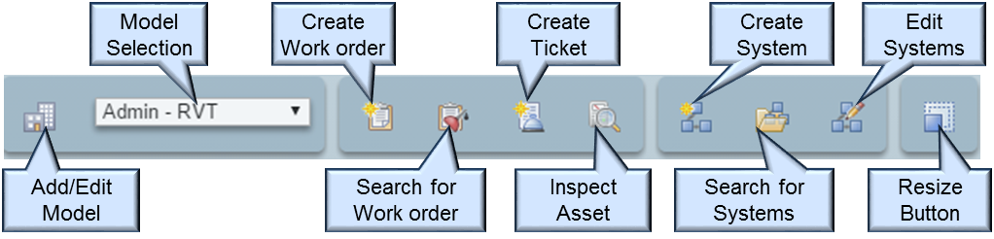

The above figure is from the Locations application. Not all of the icons shown are visible in other applications.

#### Add/Edit Model:

The Add/Edit Model button displays a dialog that you can use to add a model to the current location, or to edit the model files that are already associated with the location. Refer to section of this document, 2.6 Managing Linked Locations for instructions on how to use this dialog. This button is only displayed when the Viewer is used in the Locations application.

**Model Selection**: The Model Selection combination box displays all the models that are available for the currently selected item. Models are displayed in order of decreasing priority, then of increasing location size. Selecting a model loads that model into the Viewer. If the currently selected item(s) is available in the new model, it is automatically selected and the model is zoomed to context.

|  |  |
| --- | --- |
| Tip | *The list of models is automatically updated as the currently selected Maximo item changes either by using Maximo navigation or by selecting items in the model. However, a new model file is only loaded if the newly selected item does not exist in the currently loaded model. If a new model file is not loaded, there is no visual indication that the list of available models has changed other than by displaying the combination box selection list.* |

When a new model is selected, the Viewer attempts to select the item(s) that were selected in the previously displayed model in the new model.

**Create Work Order:**  The Create Work Order button displays a dialog to create a work order for the currently selected Maximo record. This is the same dialog that is available from the Select Action menu. This button is not available when the Viewer is used for an asset lookup.

**Search for Work Orders:**  The Search for Work Orders button displays the Display Work Details dialog. The dialog is similar to the View Work Details dialog that is available from the Select Action menu with the following differences:

* Only work orders, tickets, and preventive maintenance records are supported.
* The location that is used is always the location that is associated with the model so the search domain includes all items in the currently displayed model.

|  |  |
| --- | --- |
| Tip | *If multiple model files are available, the search can be narrowed or broadened by selecting and displaying a different model file.* |

* All or some of the assets or locations that have items in the results set can be highlighted in the model. This allows you to easy locate assets or locations visually in the model that require your attention. The Display All button highlights all items listed in the dialogs. The Display Selected button highlights the checked items.

**Create Ticket:**  The Create Ticket button displays a dialog to create a service request for the currently selected Maximo record. This is the same dialog that is available from the Select Action menu. This button is not available when the Viewer is used for asset lookup.

**Inspect Asset:** The Inspect Asset button displays the Asset Details dialog. It displays a list of all assets at the currently selected location, and all children of that location. For example, selecting an operating location such as an air handler displays the asset that is being operated at that location. Selecting a space such as a room shows all assets that are associated with the space. A table row can be expanded to show details of the asset. This button is not available when the Viewer is used with the Asset application because it is redundant with the Asset tab.

**New System:**  The New System button creates a new Maximo system from the current selection. The system created is a two level hierarchy. The parent is the location that is associated with the model file, and the children are the current selection. Depending on how the current selection is created, it may contain elements that have not been imported into Maximo, these elements are not part of the new system.

**Display Systems:**  The Display Systems button displays a dialog with a table of all the systems for which the current selection is a member except the primary system. Selecting the Display System causes all members of the system that are in the model file to be selected. Selecting the ■ icon selects and displays the associated item in the model and closed the dialog.

**Edit System:** The Edit Systems dialog enables many aspects of systems to be edited. The following functions are available for editing members of a system:

* **Replace:** Replaces all members of the system with the current selection. Similar to the New System function, the resulting system is two level. The top level is the location that is associated with the model and the next level is the current viewer selection.
* **Append:** Adds the current selection as children of the selected node. Items in the selection that are already members of the system are ignored.
* **Delete:** Removes all members from the system and deletes the system.

The effects of the above actions are immediate and are not rolled back by canceling the dialog.

The dialog can also be used to update the system description and classification, and to view and manage attachments.

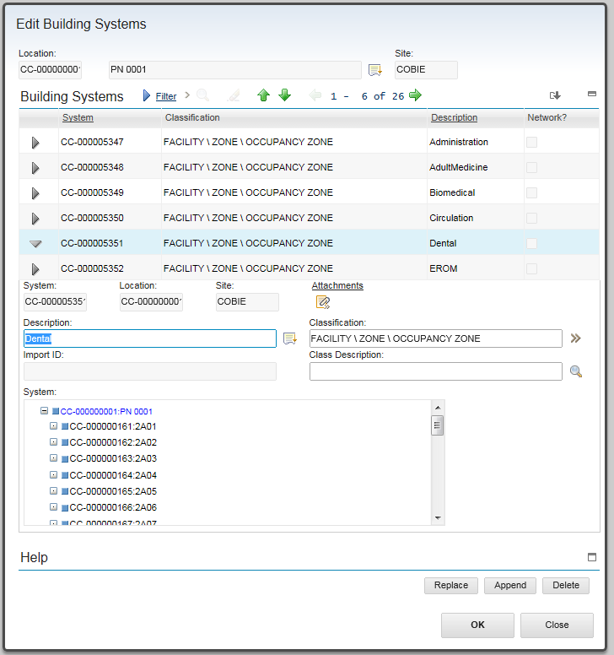

Figure - Edit Systems Dialog

**Resize:**  The Resize button displays a resize menu to aid in fitting the Viewer into the browser window. The size selection applies to the Assets, Locations, and the Work Order Tracking applications and is in effect for the duration of the browser session.

The Resize button on the Asset Lookup dialog controls only the height. There are three options. Pressing the button cycles through the options.

### Saved views

Much of the Viewer state can be captured in a Saved View that saves the settings for the current view and stores the view in the Maximo database for later use. This includes: The camera position and zoom, the current selection, and section cuts. Saved views can be found on the Maximo popup on the bottom toolbar.



**To create a Saved View:** Setup the desired viewer image, then select the Save View button on the Viewer toolbar. This displays the Save View dialog.

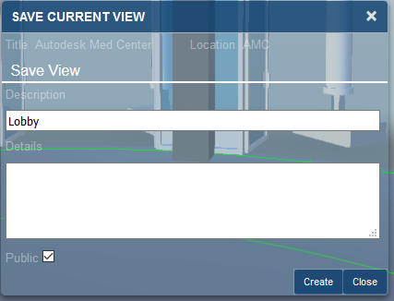

**Description:** The description is required and identifies the view for later use.

**Details:** Optional addition description

**Public:** Private views are only visible to the user who creates them. Public views are visible to all users with access to the site.

To restore a view, select the Apply Saved View button from the Viewer toolbar. Highlight the desired view and click the Apply button or double-click the desired view.

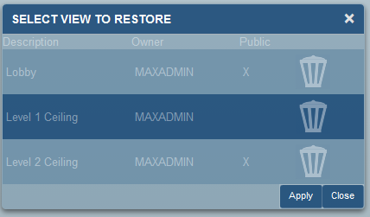

**Managing Saved views**: From the Manage BIM Viewer application, select a model to manage its saved views. To display all saved views that are associated with the model Select Action > Manage Saved Views. This displays all the Saved Views that are associated with the model.

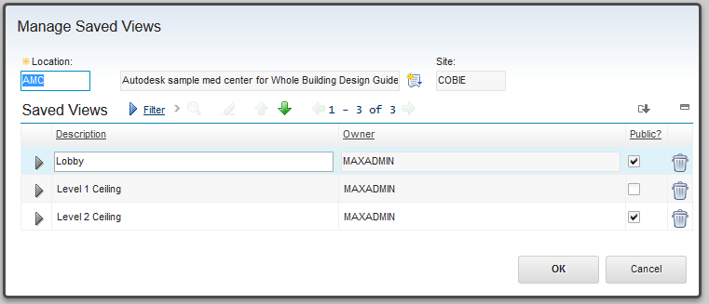

Views can be deleted from the Manage Saved Views dialog. However, views can only be created from within the Viewer.

### Asset Properties

In all of the applications that support the Viewer with the exception of the Asset application, the asset details for the currently selected asset can be displayed in the Viewer. From the viewer bottom toolbar select the Asset Detail button . The properties for the asset are listed in a property sheet style display. Properties in this view are read-only.

While the Asset property sheet is displayed, changing the selected item in the viewer updates the asset properties with to the new selection.



Several additional records are available from the Asset property sheet.

* Clicking the location entry replaces the asset properties with properties for the asset’s location. Clicking the Parent field of the Location properties moves the location up the location hierarchy.
* If the Manufacturer data is present, clicking it replaces the asset properties with Company properties.
* If the Product ID is present, clicking it replaces the asset properties with Product properties.
* If any of the records have attachments, the Attachment button is displayed. Clicking it displays the attachment list which then allows individual attachments to be displayed. Attachments are displayed in a new browser window.

When drilling down into related data, the properties sheets are stacked. For example:

* AHU-1 (asset)
* AHU-1 (Operating Location – Location)
* CC-Second Floor-2005 (Room – Location)
* CC-Second Floor (Floor – Location)

The Back button moves the location down the stack discarding the top property sheet.

Moving to a new selection discards the entire stack and displays the Asset properties for that selection.

## Viewer Navigation

Basic and extended viewer navigation and view manipulation is provided by Autodesk as part of the Forge Viewers. These functions are accessed from the bottom toolbar.

### Viewer Toolbar

The left hand three sections of the bottom toolbar are part of the basic viewer package as provided by Autodesk. This provided access to standard viewer navigation features, viewer configuration, and model properties. Several of these features are highlighted below:



The two sections to the right of the bottom toolbar contain IBM extensions and access to Maximo specific features.



**Search**: The Viewer provides a quick search for items in the model. It searches all model properties for all items for any property value that contains the search string. Any item that has a match is part of the search result and is selected.

**Navigations:**   The navigation arrows allow you to cycle the view and the current Maximo item through all the selected elements in the model. The view is zoomed and centered to display the previous or next selected item. The numbers indicate the current selection index and the total number of items selected.

**Toggle Zoom to Context:** / 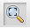 The Toggle Zoom to Context button enables or disables the auto zoom to context when moving among items in the Maximo selection list, or the individual items in a selection set.

**Go to model Location**: The Go to Model Location button is only available in the Location application. Selecting this button sets the current Maximo location to the location that is associated with the model file that is displayed in the viewer, typically a facility. Clicking on an unoccupied area of the viewer background accomplishes the same thing.

**Zoom to Selection:**  The Zoom to Selection button centers the model on the current selection and zooms the view into the current selections. If multiple items are selected, the view includes all selected items.

**Zoom to Model:**  The Zoom to Model button zooms to the view so that the entire model is displayed.

**Selection Mode:** The Selection Mode button indicates whether the Viewer is in single  or multi  selection mode. In single selection mode, only a single item may be selected. This is the default mode. When the Viewer is used with the Location or Work Order Tracking application the button can be clicked to toggle between single and mutli-select mode. Multi select mode is used for creating selection sets to use to define Maximo systems. The restriction only applies to user selection. The display work and display systems dialogs can still select multiple items. There is also a multi-select mode for the asset selection dialog in which multi-select is active.

### Model Tree

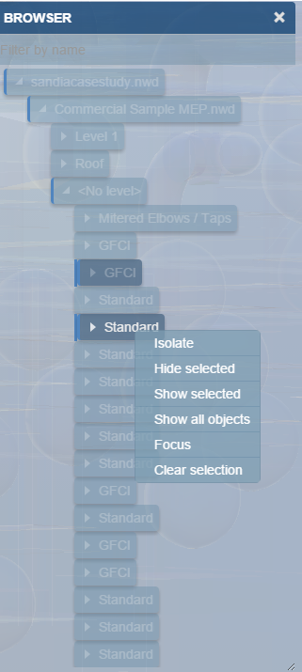

The model tree reflects the internal structure of the model. Different types of models have different structures. The model tree can be used to navigate through the model by using its structure.

## Sections

A model can be cut by a section plane in the X,Y,or Z axis, or cut by a box in all three axis at once.

Display the desired section tool and drag the arrow to move the cut plane through the model.



|  |  |
| --- | --- |
| Tip | *Use the Z section plane and the top down Orth view to create 2D floor or ceiling plans which can then be store as saved views for later use. A view down the Z axis can be created by clicking on the Top of the view cube* |

## Geo Positioning

Building models can be geo positioned. To enable this, a map provider must be configured for the site using the Map Manger application.

To geo position a building model:

1. Select the Map tab.
2. Enter an address.
3. Press the Find button. If the location selected for the model has a service address, the address information is copied onto the model.

If the location associated with the Manage BIM Viewer record has a service address, then the address is pre-populated from the location.

## Work Order Tracking

A 3D View tab is added to the Work Order Tracking application to provide visualization of both the “path to top” or location hierarchy and context in a facility of the assets that are associated with a work order. It also provides use of the viewer to easily add and remove assets or location from a work order.



**Select viewer location:** This is the standard Maximo location lookup menu. It selects the current location for the viewer independent from any other part of the work order. If a model is available for the location, it is displayed in the viewer.

**Primary asset or location:** Displays the path to top for the primary asset or location for the work order and provides for displaying it in the viewer.

**Multiple asset of location:** Displays a forest of trees showing the path to top for every asset of location in the Multiple Asset, Location, and CI table, and provides for displaying them in the viewer.

**Display in Viewer**: Selecting the ■ button for any listing in the tree displays that item in the viewer, loading the correct model file if necessary.

#### Top Toolbar

The tool bar on the Work Order Tracking application adds four functions to the standard viewer toolbar:



**Add Selection Set to Work Order**: This button adds all the assets that are currently selected in the viewer to the work order Multiple Asset, Location, and CI table.

**Remove Selection Set from Work Order**: This button removes any asset that are currently selected in the viewer and that are currently in the Multiple Asset, Location and CI table from the table. Selected items that are not in the table are ignored.

**Show Markup ** This button displays a list of all the Work Views that are associated with this model and work order. A view may be applied to the viewer by double-clicking the view description of be selecting the view description then pressing the Apply button.

**Create Markup**  This button switches the viewer to Markup Mode and displays the Markup Toolbar.

### Markup

Markup mode provides a set of drawing tools that can be used to draw on top of the view that is displayed at the time the markup mode is entered. Once in markup mode, the view cannot be changed except to zoom and pan. Once complete, the markup can be saved with the work order and displayed later. A work order can have any number of markups associated with it.

When markup mode is entered, the Markup toolbar is displayed:



#### Drawing markup

The first section of the Markup tool bar provides a set of drawing tools. The active drawing tool is highlighted. The drawing mechanism differs slightly by tool type:

**Arrow:** Click and drag.

**Cloud:** Click to place each segment. Clicking on the start closes the cloud and allows it to be filled.

**Freehand:** Hold the mouse down and drag.

**Line:** Click to place each segment. Clicking on the start closes the figure and allows it to be filled.

**Oval:** Click and drag to form the bounding box.

**Rectangle:** Click and drag to create diagonally opposite corners.

**Text:** Click to place the top left corner of the text box, then type the text. When complete, click on the background outside the text box to exit edit mode.

#### Markup Properties

The appearance of markup elements can be changed. Selecting the  button displays the Markup Properties dialog:



The dialog has two slightly different forms depending on whether the active drawing tools is the Text tool or any of the other tools.

The property setting remains in effect until it is changed. When a new tool is selected, it uses the current markup properties.

Selecting a previously drawn markup sets the current drawing properties to those used to draw the newly selected markup.

#### Editing Markup

Any previously drawn markup can be selected and edited. Click on the markup to select it. Editing options vary by markup. Generally, markups can be moved, resized, deleted, and in some cases rotated.

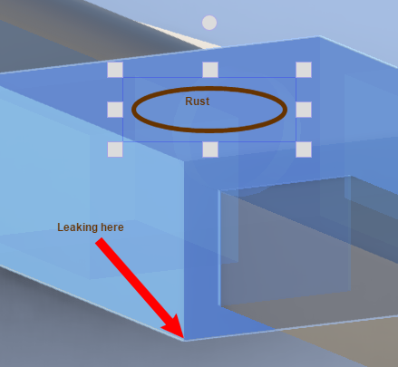

Selecting a markup also makes that markup type the currently selected drawing tool on the Markup toolbar and updates the drawing properties.

#### Save Markup

Select the  Save button to complete the markup session and to save the markup.

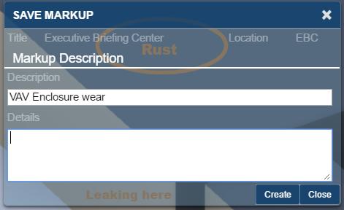

When you click the Create button, Maximo saves the just completed markup, the current view, the markup name, and any description with the work order.

#### Display Markup

Select the  button to display a list of markups that are associated with the work order.

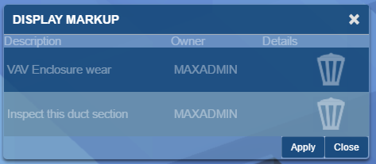

Applying a markup restores the view that was used to create the markup and displays the drawing elements of the markup. The Viewer is locked except for zoom and pan until the markup display is closed.

The **Delete** button can be used to delete the associated markup.

# Security

The Forge Viewer adds the following signature options to the Manage BIM Viewer application:

* **LMV_CLOUD** - Manage Autodesk Forge service submenu
* **LMV_BUCKET** - Manage Model Storage dialog
* **LMV_MODEL** - Manage Model Files dialog
* **LMV_VIEW** - Manage Viewable Models dialog
* **LMV_SAVE** - Manage Saved Views

On installation, rights to these options are granted to the MAXADMIN security group. To change rights:

* Navigate to > Security > Security Groups.
* Search for the security group to which you want to grant rights.
* Select the Application tab.
* Search for the Building Model Import application.
* Grant security rights as needed.
* Save your changes.

# Trouble Shooting

You can find further information on our forum located at <http://www.ibm.com/developerworks/forums/forum.jspa?forumID=2981>

## Forge Viewer

**Symptom:** SSL Error

* The singer certificate that is used by the Autodesk Forge service is not in the application server trust store. For WebSphere, this typically is the CellDefaultTrustStore, but it can vary based on the deployment type.

**Symptom:** When using Safari on iOS, the viewer returns a 401 – Unauthorized error and the model load spinner spins forever.

To resolve this error, enable cookies.

**Symptom:** When you use a NavisWorks file, the viewer doesn’t zoom to context and when you select an item that should match the imported data the following message is displayed: The selected item is not a Maximo Location/Asset.

The ID Attribute that is specified in the Manage BIM Viewer application may be incorrect. It is typically either Guid or GUID, but it may be necessary to examine the model properties in the viewer to identify the ID Property/GUID

# Appendix REST API support

## Service Methods

The BIM solution defines three REST service methods:

#### getAuthToken

Retrieves an authorization token for use by the Forge Viewer using the key and secret that are configured in the server System Properties. See

/rest/ss/BIMLMV/getAuthToken

Parameters: None

#### linkStorage

Imports an existing storage container into Maximo

#### See section 2.1 Managing Model Storage

Example call:

http://192.168.0.106/maxrest/rest/mbo/bimlmvbucket?~storageName=buildingsmart&~appendKey=true&~orgId=PUBLIC&~description=Sample%20models%20from%20BuildingSmart&~siteId=COBIE

x-http-method-override, linkStorage

Parameters:

|  |  |
| --- | --- |
| storageName: | The base name of an existing storage container. |
| Description: | The descriptive information. |
| siteId: | Restricts access to the storage container to the specified site. |
| orgId: | Restricts access to the storage container to the specified organization. |
| appendKey: | If true, the Forge service key form the system property: 'bim.viewer.LMV.secret' is appended to the storage name. |

#### linkModel

Imports a previously uploaded model into Maximo, and optionally a previously registered viewable format into Maximo.

See section 2.3 Managing Model Files

Example call:

http://192.168.0.106/maxrest/rest/mbo/bimlmvmodel?~storageName=buildingsmart2s23v1a2uihpnjq2nljjixykqaaoinjy&~orgId=PUBLIC&~description=BuildingSmart%20sample%20office%20-%20MEP&~linkViewable=false&~modelName=office_mep.rvt&~siteId=COBIE

x-http-method-override, linkModel

Parameters:

|  |  |
| --- | --- |
| storageName: | The full name of the storage container including the appended key, if applicable. |
| description: | The descriptive information. |
| modelName: | The unique name that is given to the model. |
| siteId: | Restricts access to the model to the specified site.   * If the storage container specifies and organization, this site must be a member. * If the storage container specifies a site, this must match. |
| orgId: | Restricts access to the model to the specified organization   * If the storage container specifies an organization, this must match. |
| linkViewable: | If true, the viewable format for the model is also linked. The viewable format must have been previously registered. The entire operation will fail if the viewable format does not exist. |

All of the above methods make calls to the Autodesk View and Data API. Maximo provides no mechanism to report detailed errors from this API back to the service method caller. However, errors are logged in the application server log file .

## Object Structures

The BIM solution defines the following object structures:

|  |  |  |  |
| --- | --- | --- | --- |
| Name | Description | Parent | Children |
| BIMASSETMODELS | Provides models for launch in the context of BIM mobile viewer | ASSET | BUILDINGMODEL |
| MXBIMLMVMODEL | The Autodesk Forge Viewer Model definition | BIMLMVMODEL | BIMLMVMODELUPLOAD  BIMLMVMODELLINK |

# Appendix – Summary of Database updates

Installing the extensions makes the following changes to the Maximo database:

## Tables Created:

The Forge Viewer integration uses the following tables to save the viewer state:

* **BIMLMVSAVEDVIEW** – Saved viewer state that is associated with a model.
* **BIMLMVWORKVIEW** – Saved viewer state that s associated with a work order.

The Forge integration merges Maximo data with data that is stored in the Autodesk Forge service. Each of the following tables defines several non-persistent attributes. This data is actually persisted in the Autodesk Forge service and loaded via REST each time a Mbo is instantiated.

* **BIMLMVBUCKET** **–** Theunstructured storage location in the Autodesk Forge service for model files and the Maximo Storage Container object
* **BIMLMVBUCKETACCESS** **–** The proxy object for model files that are stored in the Autodesk Viewer cloud.
* **BIMLMVMODEL** **–** The proxy object for model files that are stored in the Autodesk Viewer cloud.
* **BIMLMVMODELLINK** **–** Links that are related to models for viewer translation.
* **BIMLMVMODELUPLOAD** **–** Theaudit record and status of model file uploads.
* **BIMLMVVIEWABLE** **–** The proxy object for viewable models that are stored in the Autodesk Viewer cloud.

## Synonym Domains Added

* **BIMLMVBUCKETPOLICY** - How long are objects stored in the bucket are retained? See section 2.1.1 Creating a storage container:
* **BIMLMVBUCKETACCESS** - Access rights to storage

 ®

© Copyright IBM Corporation 2011

IBM United States of America

Produced in the United States of America

US Government Users Restricted Rights - Use, duplication or disclosure restricted by GSA ADP Schedule Contract with IBM Corp.

IBM may not offer the products, services, or features discussed in this document in other countries. Consult your local IBM representative for information on the products and services currently available in your area. Any reference to an IBM product, program, or service is not intended to state or imply that only that IBM product, program, or service may be used. Any functionally equivalent product, program, or service that does not infringe any IBM intellectual property right may be used instead. However, it is the user's responsibility to evaluate and verify the operation of any non-IBM product, program, or service.

IBM may have patents or pending patent applications covering subject matter described in this document. The furnishing of this document does not grant you any license to these patents. You can send license inquiries, in writing, to:

IBM Director of Licensing  
IBM Corporation  
North Castle Drive  
Armonk, NY 10504-1785   
U.S.A.

**The following paragraph does not apply to the United Kingdom or any other country where such provisions are inconsistent with local law:**

INTERNATIONAL BUSINESS MACHINES CORPORATION PROVIDES THIS PAPER “AS IS” WITHOUT WARRANTY OF ANY KIND, EITHER EXPRESS OR IMPLIED, INCLUDING, BUT NOT LIMITED TO, THE IMPLIED WARRANTIES OF NON-INFRINGEMENT, MERCHANTABILITY OR FITNESS FOR A PARTICULAR PURPOSE. Some states do not allow disclaimer of express or implied warranties in certain transactions, therefore, this statement may not apply to you.

This information could include technical inaccuracies or typographical errors. Changes may be made periodically to the information herein; these changes may be incorporated in subsequent versions of the paper. IBM may make improvements and/or changes in the product(s) and/or the program(s) described in this paper at any time without notice.

Any references in this document to non-IBM Web sites are provided for convenience only and do not in any manner serve as an endorsement of those Web sites. The materials at those Web sites are not part of the materials for this IBM product and use of those Web sites is at your own risk.

IBM may have patents or pending patent applications covering subject matter described in this document. The furnishing of this document does not give you any license to these patents. You can send license inquiries, in writing, to:

IBM Director of Licensing

IBM Corporation

4205 South Miami Boulevard

Research Triangle Park, NC 27709 U.S.A.

All statements regarding IBM's future direction or intent are subject to change or withdrawal without notice, and represent goals and objectives only.

This information is for planning purposes only. The information herein is subject to change before the products described become available.

If you are viewing this information softcopy, the photographs and color illustrations may not appear.

**Trademarks**

IBM, the IBM logo, and ibm.com are trademarks or registered trademarks of International Business Machines Corporation in the United States, other countries, or both. If these and other IBM trademarked terms are marked on their first occurrence in this information with a trademark symbol (® or ™), these symbols indicate U.S. registered or common law trademarks owned by IBM at the time this information was published. Such trademarks may also be registered or common law trademarks in other countries. A current list of IBM trademarks is available on the web at "Copyright and trademark information" at <http://www.ibm.com/legal/copytrade.shtml>.

Autodesk, the Autodesk logo, BIM360, NavisWorks, Revit, Forge are registered trademarks or trademarks of Autodesk, Inc., and/or its subsidiaries and/or affiliates in the USA and/or other countries. All other brand names, product names, or trademarks belong to their respective holders. Autodesk reserves the right to alter product and services offerings, and specifications and pricing at any time without notice, and is not responsible for typographical or graphical errors that may appear in this document. © [2016] Autodesk, Inc. All rights reserved.

Microsoft, Windows, Windows NT, and the Windows logo are trademarks of Microsoft Corporation in the United States, other countries, or both.

Other company, product, or service names may be trademarks or service marks of others.

**Notices**

Apache POI

Copyright 2009 The Apache Software Foundation

This product includes software developed by The Apache Software Foundation (<http://www.apache.org/>).

This product contains the DOM4J library (<http://www.dom4j.org>). Copyright 2001-2005 (C) MetaStuff, Ltd. All Rights Reserved.

This product contains parts that were originally based on software from BEA. Copyright (c) 2000-2003, BEA Systems, <http://www.bea.com/>.

This product contains W3C XML Schema documents. Copyright 2001-2003 (c) World Wide Web Consortium (Massachusetts Institute of Technology, European

Research Consortium for Informatics and Mathematics, Keio University)

This product contains the Piccolo XML Parser for Java (http://piccolo.sourceforge.net/). Copyright 2002 Yuval Oren.